Animated Face

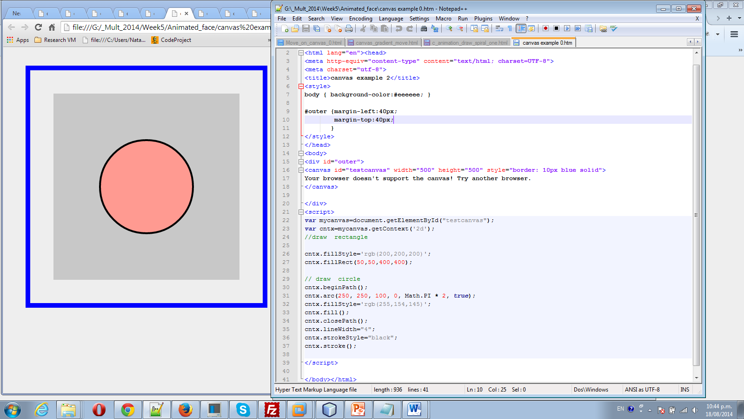

Add eyes:

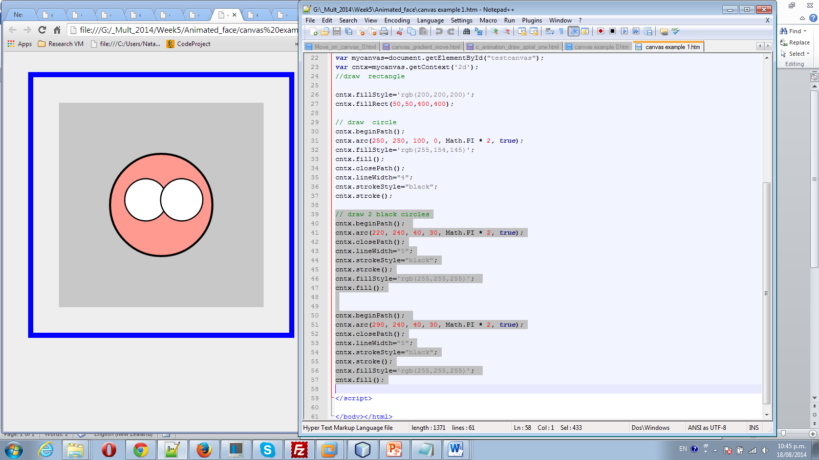

Add red semi-circle (mouth) and blue middle eyes:

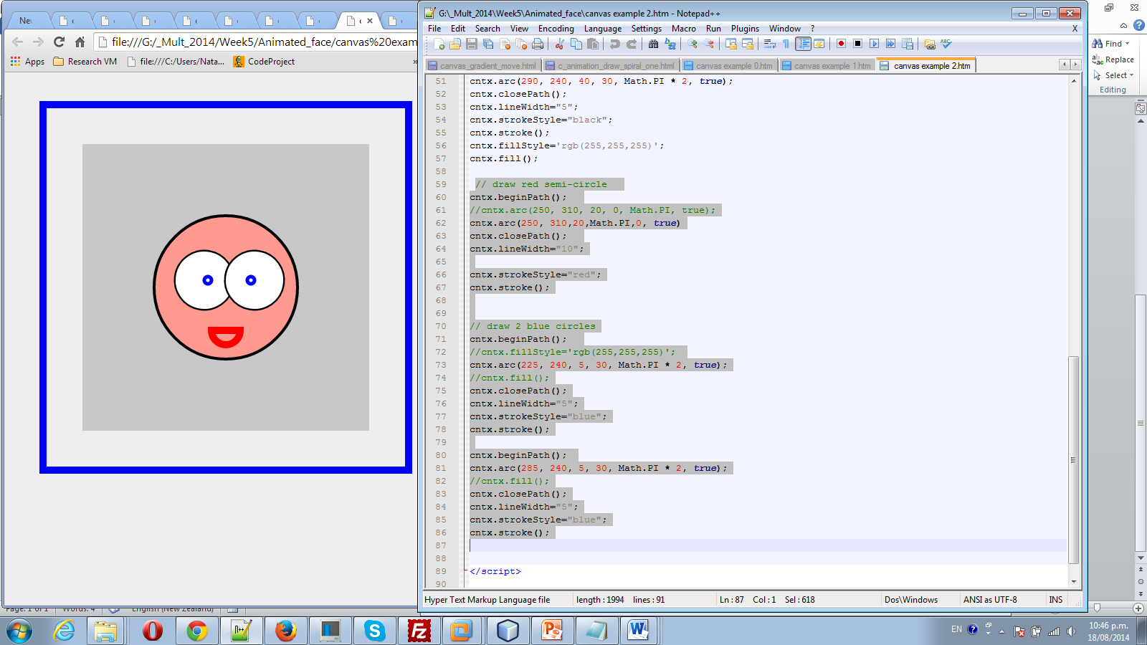

Add movement

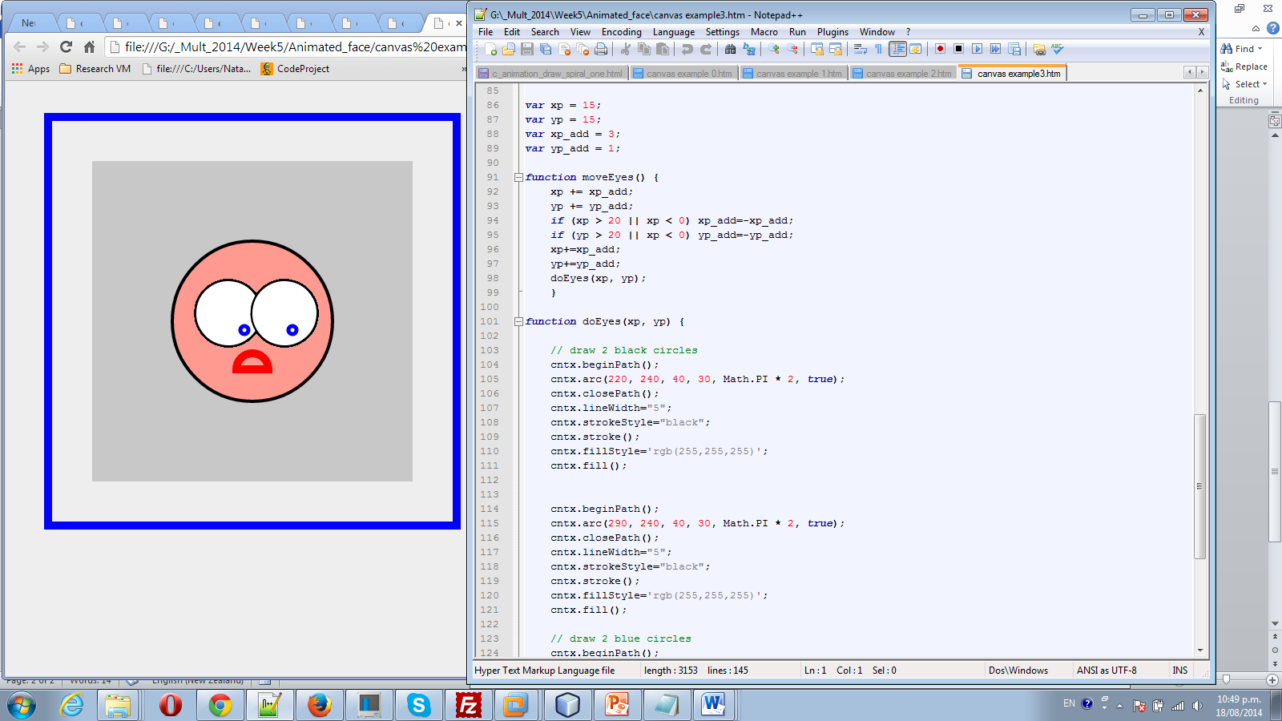

var xp = 15;

var yp = 15;

var xp_add = 3;

var yp_add = 1;

function moveEyes() {

xp += xp_add;

yp += yp_add;

if (xp > 20 || xp < 0) xp_add=-xp_add;

if (yp > 20 || xp < 0) yp_add=-yp_add;

xp+=xp_add;

yp+=yp_add;

doEyes(xp, yp);

}

function doEyes(xp, yp) {

// draw 2 black circles

cntx.beginPath();

cntx.arc(220, 240, 40, 30, Math.PI * 2, true);

cntx.closePath();

cntx.lineWidth="5";

cntx.strokeStyle="black";

cntx.stroke();

cntx.fillStyle='rgb(255,255,255)';

cntx.fill();

cntx.beginPath();

cntx.arc(290, 240, 40, 30, Math.PI * 2, true);

cntx.closePath();

cntx.lineWidth="5";

cntx.strokeStyle="black";

cntx.stroke();

cntx.fillStyle='rgb(255,255,255)';

cntx.fill();

// draw 2 blue circles

cntx.beginPath();

//cntx.fillStyle='rgb(255,255,255)';

cntx.arc(225 + xp, 240 +yp, 5, 30, Math.PI * 2, true);

//cntx.fill();

cntx.closePath();

cntx.lineWidth="5";

cntx.strokeStyle="blue";

cntx.stroke();

cntx.beginPath();

cntx.arc(285 + xp, 240 + yp, 5, 30, Math.PI * 2, true);

//cntx.fill();

cntx.closePath();

cntx.lineWidth="5";

cntx.strokeStyle="blue";

cntx.stroke();

}

setInterval(moveEyes, 200);

</script>